KUMARESAN K R

## Performance Chart:

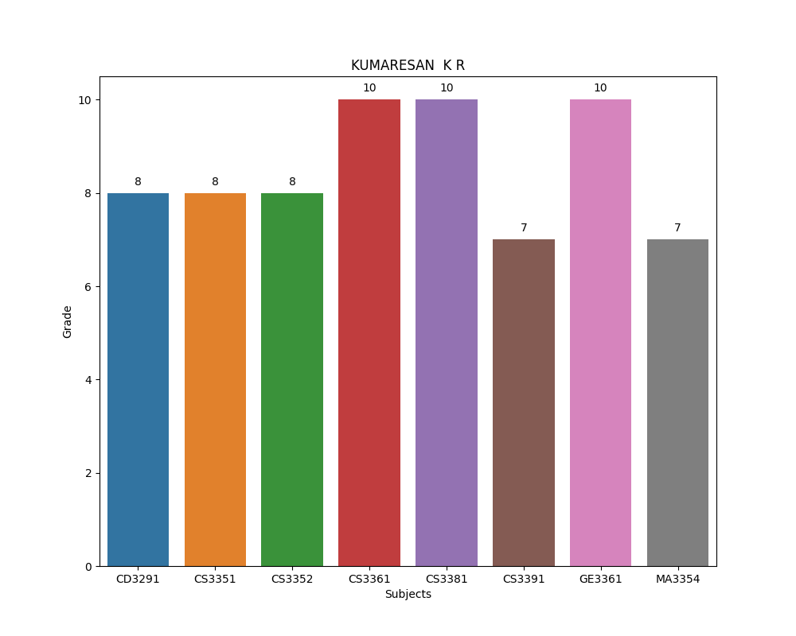

## Performance Details:

Student is get 'O' grade in CD3281 subject.  
Student is get 'A' grade in CD3291 subject.  
Student is get 'A' grade in CS3351 subject.  
Student is get 'A' grade in CS3352 subject.  
Student is get 'O' grade in CS3361 subject.  
Student is get 'O' grade in CS3381 subject.  
Student is get 'B+' grade in CS3391 subject.  
Student is get 'O' grade in GE3361 subject.  
Student is get 'B+' grade in MA3354 subject.